**Follow up (Data analysis and modeling): -**

**Recommendations to coaches and players through visualizations:**

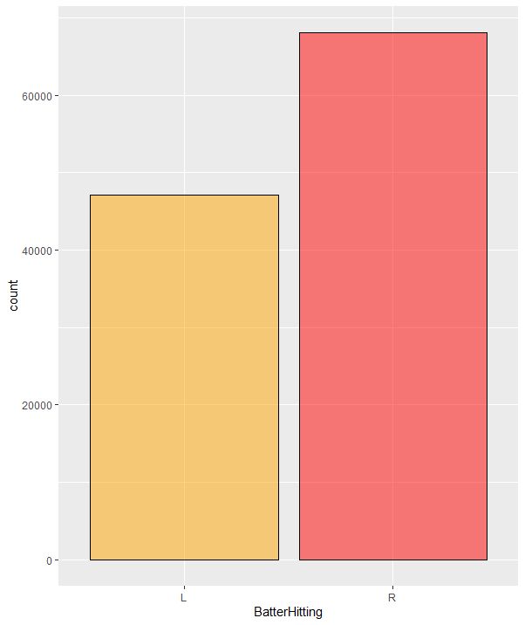

Firstly, I would suggest the pitchers of the team prepare in general more for right-handed batsman as there are around **30%** more right-handed batters as compared to left-handed ones. Although they should not ignore practicing to left-handed batters as there can be exceptional cases and our team may face an opponent with a majority of left-handed batters.

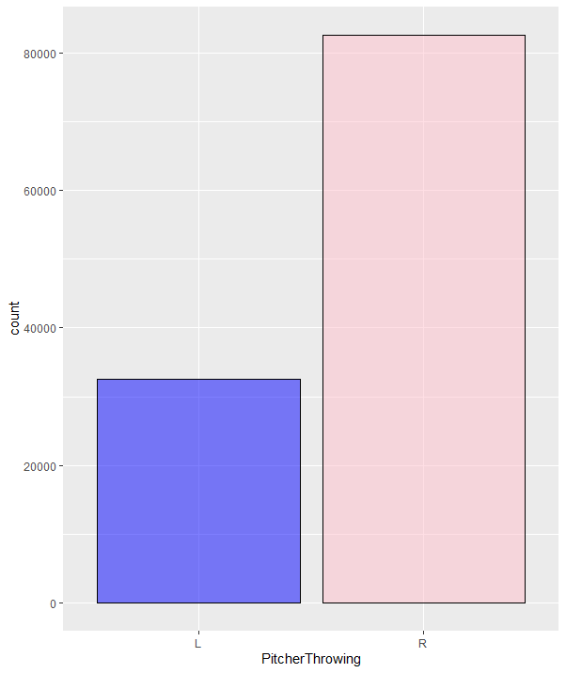

Similarly, for the Batters of our team, I would suggest the same and they can focus even more on facing the right-handed pitchers as they are about **50-60%** more than the left-handed pitchers. Still, there can be an exception that we might face a team with most of the left-handed pitchers. So, our preparation should consider this factor too. Although the odds of this happening are pretty less.

Secondly, I would suggest the Batters of our team to prepare for the **forkbal**l the most as there is a very high percentage of these pitch types used by the pitchers.

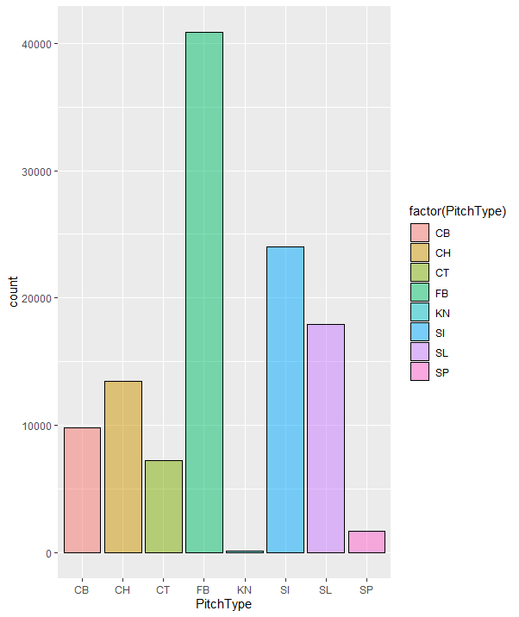

Thirdly, I would recommend the coach to train the batters with the machine set at a speed between **85 and 98 miles/hour** as a large portion of the pitches are delivered at a speed in this range.

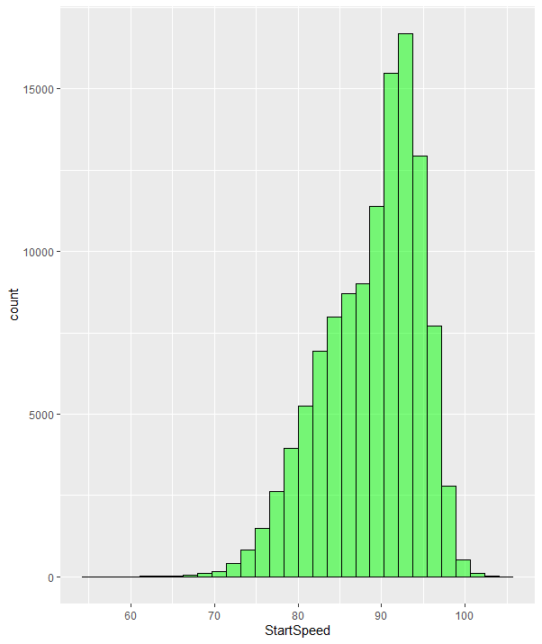

**Recommendations to coaches and players through modeling:**

The regression model suggests that the most important features for a batted ball being a hit are as follows:

1. Plate appearance – Plate appearance of the inning.
2. Angle-Angle of the bat in which the ball was hit.
3. Direction -Angle of the bat on contact and home plate.

I would have a session with the coach after analyzing the distribution of these columns and collectively create a training schedule for the batters to adopt these specifications to improve the chance of a ball being a hit.

1. Vert break – How much vertical movement the pitch generates.

I would try to contact the technical research team about this if we are making our own pitching machines or else contact the vendor to make a machine in which pitch vertical angle can be set accordingly.